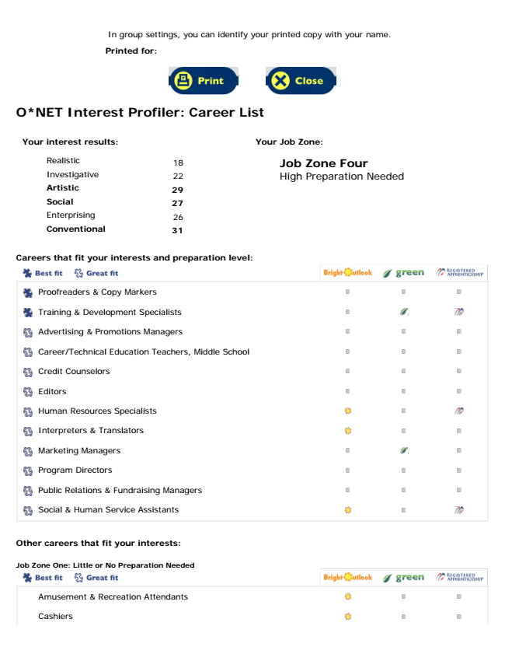

**O*NET Interest Profiler: Career List**

**Your interest results:**

Realistic

18 Investigative

**22 Artistic**

**29 Social**

27 Enterprising

**26 Conventional**

**31**

**Your Job Zone:**

Job Zone Four High Preparation Needed

**Careers that fit your interests and preparation level:**

Social & Human Service Assistants

**Other careers that fit your interests:**

**Job Zone One: Little or No Preparation Needed**

Proofreaders & Copy Markers

Training & Development Specialists

Advertising & Promotions Managers

Career/Technical Education Teachers, Middle School

Credit Counselors

Editors

Human Resources Specialists

Interpreters & Translators

Marketing Managers

Program Directors

Public Relations & Fundraising Managers

Amusement & Recreation Attendants

Cashiers

In group settings, you can identify your printed copy with your name.

**Printed for:**

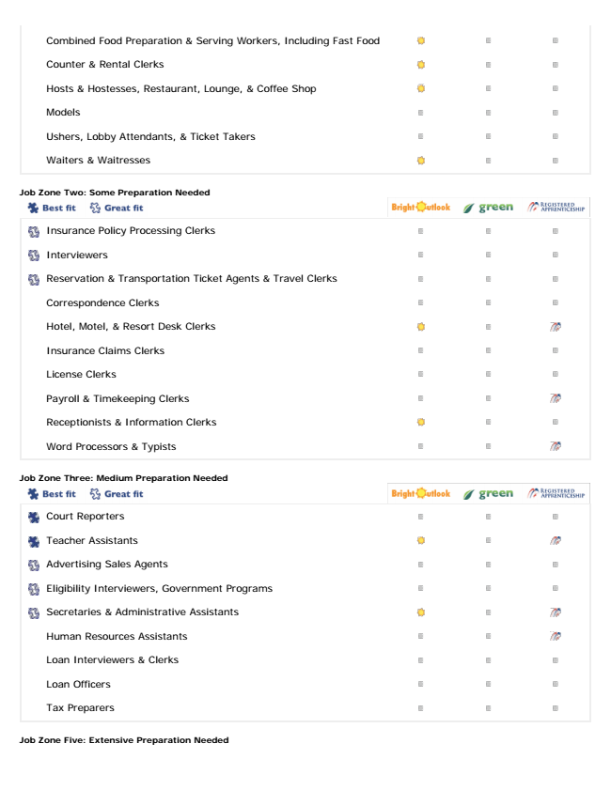

Waiters & Waitresses

**Job Zone Two: Some Preparation Needed**

Word Processors & Typists

**Job Zone Three: Medium Preparation Needed**

Tax Preparers

**Job Zone Five: Extensive Preparation Needed**

Combined Food Preparation & Serving Workers, Including Fast Food

Counter & Rental Clerks

Hosts & Hostesses, Restaurant, Lounge, & Coffee Shop

Models

Ushers, Lobby Attendants, & Ticket Takers

Insurance Policy Processing Clerks

Interviewers

Reservation & Transportation Ticket Agents & Travel Clerks

Correspondence Clerks

Hotel, Motel, & Resort Desk Clerks

Insurance Claims Clerks

License Clerks

Payroll & Timekeeping Clerks

Receptionists & Information Clerks

Court Reporters

Teacher Assistants

Advertising Sales Agents

Eligibility Interviewers, Government Programs

Secretaries & Administrative Assistants

Human Resources Assistants

Loan Interviewers & Clerks

Loan Officers

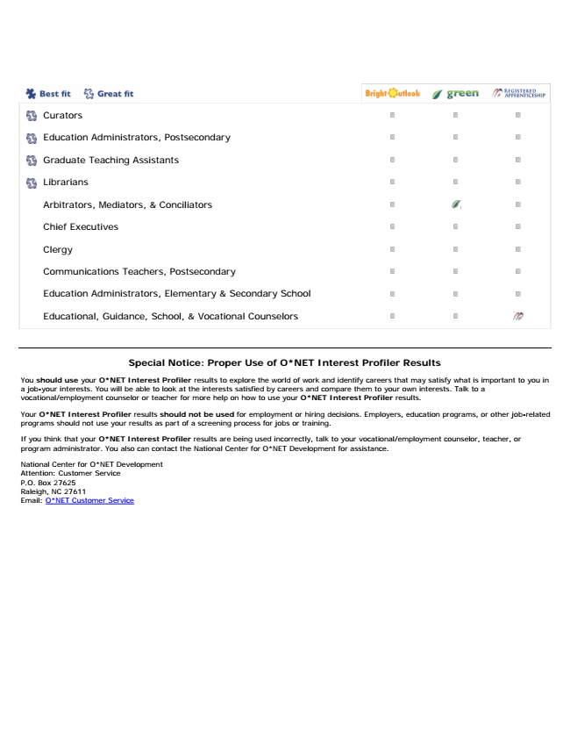

Educational, Guidance, School, & Vocational Counselors

**Special Notice: Proper Use of O*NET Interest Profiler Results**

You should use your O*NET Interest Profiler results to explore the world of work and identify careers that may satisfy what is important to you in a job-your interests. You will be able to look at the interests satisfied by careers and compare them to your own interests. Talk to a vocational/employment counselor or teacher for more help on how to use your O*NET Interest Profiler results.

Your O*NET Interest Profiler results should not be used for employment or hiring decisions. Employers, education programs, or other job-related programs should not use your results as part of a screening process for jobs or training.

If you think that your O*NET Interest Profiler results are being used incorrectly, talk to your vocational/employment counselor, teacher, or program administrator. You also can contact the National Center for O*NET Development for assistance.

National Center for O*NET Development Attention: Customer Service P.O. Box 27625 Raleigh, NC 27611 Email: O*NET Customer Service

Curators

Education Administrators, Postsecondary

Graduate Teaching Assistants

Librarians

Arbitrators, Mediators, & Conciliators

Chief Executives

Clergy

Communications Teachers, Postsecondary

Education Administrators, Elementary & Secondary School